THE BAR COUNCIL OF KERALA CERTIFICATE OF ENROLMENT

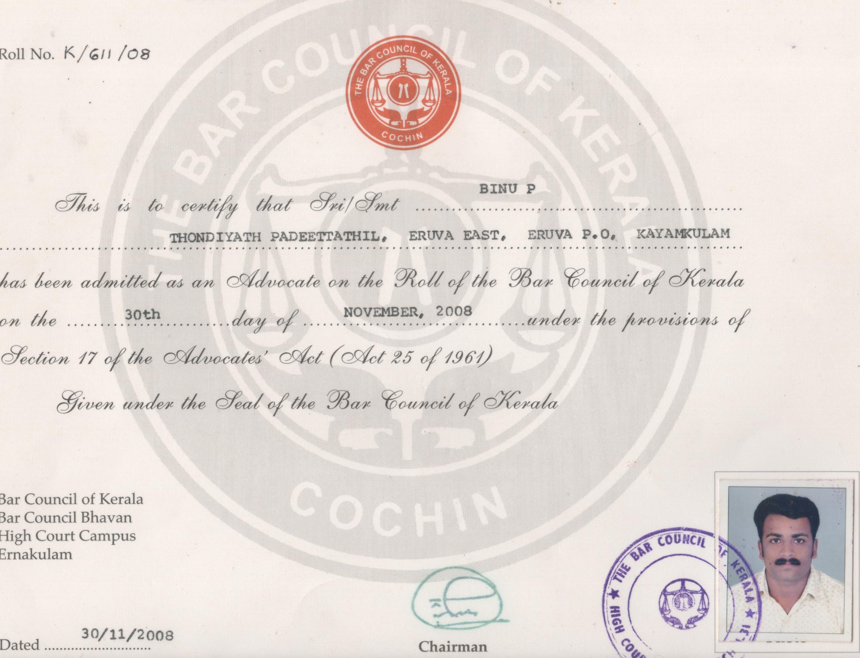

Roll

La'

Bar

Bar

High

Ernakulam